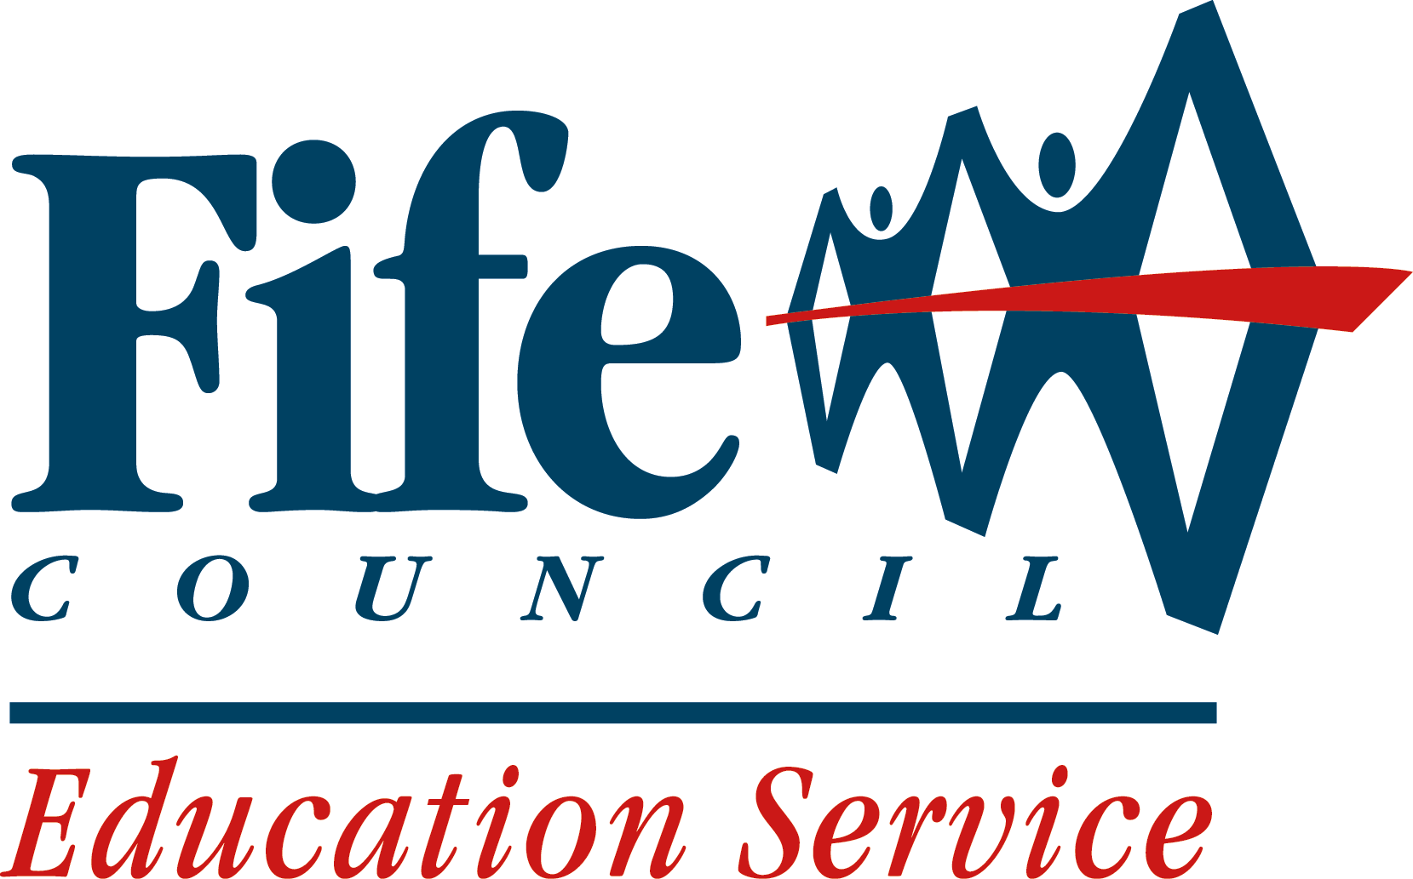

Restorative Approaches

Self-evaluation toolkit for schools

Developing Restorative Approaches in schools represents in some ways a significant departure from well established methods of dealing with indiscipline, misbehaviour and relationship difficulties. Historically, approaches to managing such concerns have developed from a punishment based model. Although recent years have witnessed a significant shift towards more positive approaches, there is little doubt of the currency of view in secondary schools that the primary response to unacceptable or inappropriate behaviour should be negative.

Restorative Approaches in education have been developing in Scotland over the past 3 years as the result of a SEED funded pilot programme involving Fife, North Lanarkshire and Highland Councils. Although each of the authorities has taken a slightly different approach to development, a clear set of core principles are shared. These derive from the original pioneering application of restorative practice within criminal justice settings, and can be summarised as an approach to offending and inappropriate behaviour which puts repairing harm done to relationships and people over and above the need for assigning blame and dispensing punishment.

This approach can represent a real challenge to more traditional views, and research clearly indicates that the successful adoption and development of restorative practice within an organisation is crucially dependent on the prevailing ethos and culture. This research and local experience consistently indicate 4 key factors which impact directly on an organisation’s readiness to adopt Restorative Approaches. The purpose of this self-evaluation instrument is to make schools aware of these factors, enable them to relate them to areas of existing effective practice, and identify possible areas for development to ensure the creation of a receptive culture.

Central to the adoption of Restorative Approaches is the principle that all members of the organisation or community need to have a sense of involvement, and that there should be some broad commonly held values within the organisation which are consistent with a Restorative Approach.

Schools are, of course, complex organisations made up of a range of individuals, and it is unlikely that all staff agree about everything – especially something as potentially controversial and challenging as Restorative Approaches. However we believe that the process of seeking staff views about the key factors will engage and involve staff in the development, and clearly identify areas where further preparatory work might need to be undertaken.

There are a number of ways in which the self-evaluation instrument can be used, and you will know which one will be best for your school. For example, it can be used as a straightforward questionnaire, with the collated results forming the basis of a feedback and planning activity.

Alternatively the questions can be used as a basis for discussion, again with action points being noted. This can be done as a whole school or as groups, with feedback being collated and analysed e.g. the results of the self-evaluation may indicate a particular department/team within the school which shows clear evidence of ‘readiness’.

Research has shown that initial development of Restorative Approaches on a small scale within a large organisation can be a particularly effective way to implement a change in culture over time, so this team/department may well serve as the starting point to develop and embed Restorative Approaches across a secondary school.

In considering the readiness of the school community to adopt Restorative Approaches, it may also be helpful to consider additional evidence which would indicate an openness to cultural and relational change. In all of these activities it can be very helpful to enlist the help of a ‘critical friend’ who will ask insightful and challenging questions about the views generated.

This self-evaluation model is of course underpinned by the three key questions referred to in How Good Is Our School 3 (2007):

- How are we doing?
- How do we know?
- What are we going to do now?

Whichever method is adopted the key aim is to arrive at a genuine picture of where the school is in relation to a number of key areas which we know relate to how effectively restorative approaches can be developed and sustained across the whole school.

The pages that follow contain the self-evaluation toolkit. It can be used in whichever way you consider best for your own school. You will also receive an electronic copy of this material. Please ensure that the school’s name is visible on the returns.
Factor 1: Meetings. communication, agreements
Meetings, both formal and informal, along with everyday conversations, are one of the main ways in which restorative approaches are used and developed. It is important to know how well staff understand the ways in which they can be most effective in meetings.

Key questions:

- Meetings are a valuable opportunity to problem solve.

 | Agree | Not sure | Disagree
- Meetings about difficult topics always generate emotions; these should be acknowledged and dealt with in the meeting.

 | Agree | Not sure | Disagree

- I possess effective skills in managing, contributing to and supporting others in meetings.

 | Agree | Not sure | Disagree

- It’s helpful to analyse and reflect on the outcome of meetings, especially difficult ones, afterwards.

 | Agree | Not sure | Disagree

Areas for development, and proposed action:

- Factor 2: Apologies, reparation, behaviour change

Being able to offer genuine, sincere apologies for behaviour is one of the most important factors in developing restorative approaches. It can help to repair any harm which has been done. Also the belief that young people can change their behaviour is a cornerstone of the approach.

Key questions:

- A genuine apology is an opportunity for all involved in an incident or a situation to move on.

 | Agree | Not sure | Disagree
- Young people can be supported to gain better understanding of their behaviour and its consequences, and what to do to make things better.

 | Agree | Not sure | Disagree

- Making reparation is a useful process in resolving difficult incidents or situations.

 | Agree | Not sure | Disagree

- Young people’s behaviour can change.
 | Agree | Not sure | Disagree

Areas for development, and proposed action:

Factor 3: Social integration

Human beings are social animals, and seek relationships and involvement with others. Responses to unacceptable behaviour sometimes involve the social exclusion of those who have misbehaved. A restorative perspective suggests that this approach rarely brings about effective long term change in behaviour, and is more likely to cause further harm.

Key questions:

- Social inclusion encourages the development of acceptable behaviour and attitudes.

 | Agree | Not sure | Disagree
- Membership of social groups is important to young people, even when they find this difficult.

 | Agree | Not sure | Disagree

- Young people who are struggling to participate in social groups can be supported to do this more effectively.

 | Agree | Not sure | Disagree

- Punishment, criticism and social exclusion can have negative consequences, and may act against positive long term change.
 | Agree | Not sure | Disagree

Areas for development, and proposed action:

Factor 4: Involvement and participation

Relationships and behaviour have a widespread impact on both a day to day basis, and in terms of the development of ethos or culture of an organisation. It is therefore important that there is consistent practice and policy across the organisation in key areas such as managing behaviour and relationships. All staff have a contribution to make in developing these.

Key questions:

- All staff contribute meaningfully to the development and review of effective policies and practice regarding behaviour and relationships.

 | Agree | Not sure | Disagree

- Staff are supported in the development of key skills in managing behaviour and relationships.

 | Agree | Not sure | Disagree

- Staff feel valued and supported.

 | Agree | Not sure | Disagree

- Staff model positive social relationships and behaviour.

 | Agree | Not sure | Disagree

Areas for development, and proposed action:

